**Electric Vehicle's Charging Network Management with**

**Machine Learning**

[Smart Internz IBM](https://docs.google.com/document/d/1vmPviuqY-kjXOkkebg1i64Zm_zpQyRUzi3SVWjBaiOk/edit)

**1 INTRODUCTION**

**1.1 Overview**

An electrical vehicle (EV) is a vehicle that uses electricity as its fuel instead of petroleum. Just like mobile phones, they need to be charged every time if the battery runs out for them to keep functioning. This is where an EV charger comes into play. An EV charger uses electrical current from the grid it’s hardwired into or a regular 240v outlet to produce enough electricity to be able to charge an EV vehicle just like any other electronic device that you would charge at your home. Just like how different mobile phones have different cables and adapters (USB-C cord, Mini-USB etc.), EV cars have a similar thing. For example, Tesla has their own unique chargers and they cannot be used with other EV vehicles. With all these limitations it is only natural that a problem arises when there are not enough available chargers, or when they are not functioning. This could occur due to unexpected peak load or due to voltage problems in the distribution network. Our solution enables the charging network industry to better understand and manage chargers using data analysis and machine learning techniques. For the solution, we’ve used the real life dataset of EV charging in Delhi, sorted them by the number of cars charged at each charging station, and then further categorized them in an hourly range for every day. With the help of this information, we can find the peak hours for when the most number of people are at the charging station. This in turn helps us to find out the peak hours of the day when the maximum voltage is used. Charging network providers can make use of these insights to distribute chargers according to the need in the particular area, ensuring appropriate voltage supply to each power station. Being able to optimize the chargers encompasses minimized power wastage, and voltage overloading would positively impact the efficiency of the chargers, resulting in better efficiency, minimal costing, as well as a better end-user experience.

**1.2 Purpose**

The main purpose of this project is to make it easier for network providers to optimise te efficiency of chargers placed around a certain area so as to maximize the energy output and cater to the needs of the users. A crucial part of being able to achieve this would be by calculating the peak hours of EV charging as well as the number of EV cars checking in and out of a station every day. This would help in redistributing the already installed chargers efficiently as well as install new chargers if need be. To reiterate, the sole purpose of this project is so make things easier for the network providers by giving them access to the much needed information about the EV charging patterns as well as ultimately making it easier for the end user to be able to charge their vehicle by the well managed system that would be put into place by the energy network providers.

**2 LITERATURE SURVEY**

**2.1 Existing problem**

EV’s have recently started to get popular in India. Vastly adopting the EV vehicles in urban areas have already started to pose a challenge in the efficiency of the power grid due to the significant amounts of energy needed for their changing. It becomes important to manage these power grids and improve the energy utilization which is being generated by renewable energy sources. Unexpected peak load and voltage problems in the distribution network are some of the challenges being faced right now due to the increasing uptake of electric vehicles. There have been attempts to devise schemes capable of energy management but due to it being challenging to keep track of EV charging at a large scale in a cost-effective way, there hasn’t been any proper successful design that has been created yet.

**2.2 Proposed solution**

As per the research done so far, there exist no prior developments in this EV charging networks field. Our solution targets not just a single charging station but all the stations that exist in Delhi. People have tried to work out, and even have proposed solutions for maximizing efficiency for the individual charging stations at the individual scale that is limited to the particular charger but none of them proposes it as a whole for all the chargers around. We propose is to incorporate the data of all the charging stations together, then assess the individual needs of each (including energy outputs and peaks), and set them up accordingly. Our solution makes this possible, it enables charging network providers to get an accurate analysis of the hourly revenue generated, energy consumed, as well as the number of cars that checked in and out using better data visualization techniques on tools like IBM Cognos.

**3 THEORITICAL ANALYSIS**

**3.1 Block diagram**

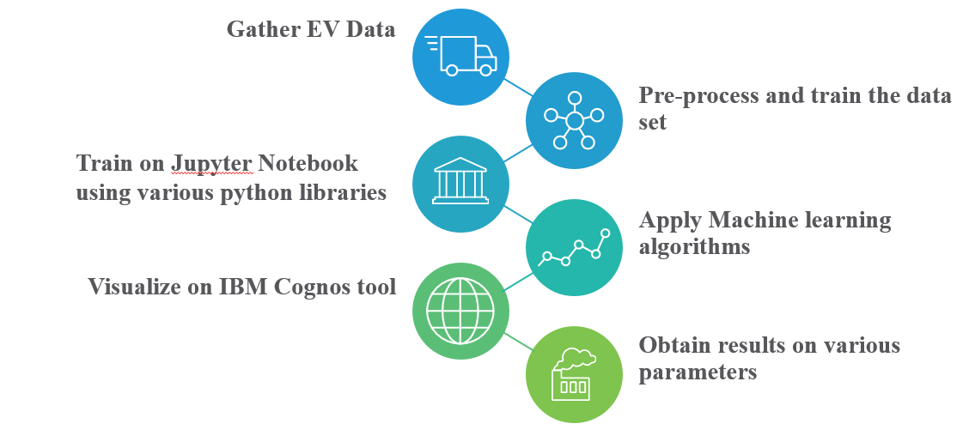

**3.2 Hardware / Software designing**

Jupyter Notebook

IBM Cognos

Anaconda

**4 EXPERIMENTAL INVESTIGATIONS**

An important analysis made while working on the solution was that, there were some charging stations where regularly ample amount of chargers were being left free while at other places there was always traffic and people waiting to use the charger. This hinted on the fact that a key problem to exist might also be that there are enough amount of chargers placed all over New Delhi but not distributed to each charging station appropriately and rather are randomly put anywhere. Luckily, with the data we have collected, it makes it possible for us to analyse the efficiency of the charging networks and to recognize the charging station which are having an excess amount of chargers as well as the charging stations with a scarce amount of them. And then redistribute the chargers in a well thought out way to be able to manage and optimise the incoming EV traffic at these stations. Another thing we noticed is that the chargers are not only different in terms of being different for various car models but also that there are three main types of chargers, i.e. Rapid chargers, fast chargers and slow chargers. The only difference between them is about the input and output voltage which makes a significant difference in the speed in which an EV vehicle is charged. What ends up happening is that the user is unaware that there are three different types of chargers available for his vehicle to be charged with. More often than not, the user unknowingly ends up using the slow charger, which ends up taking a longer time to charge his vehicle. There are times when there are multiple vehicles waiting to use a charger and using the slow charger only causes the traffic to increase. The majority of the slow chargers are rated at 3.6kW and will recharge a vehicle in about eight to twelve hours. These chargers had come into market when EV’s were initially launched and are still present in some of the charging stations. These are mostly suited for overnight charging and are best for installing at your home or workplace. But slowly all these will be replaced by rapid chargers and this problem should be sorted.

**5 FLOWCHART**

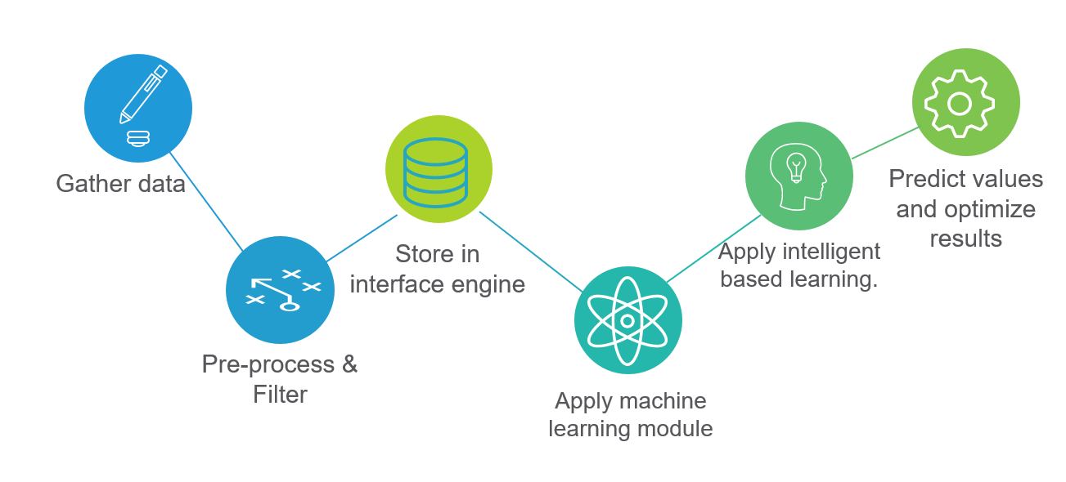

**6 RESULT**

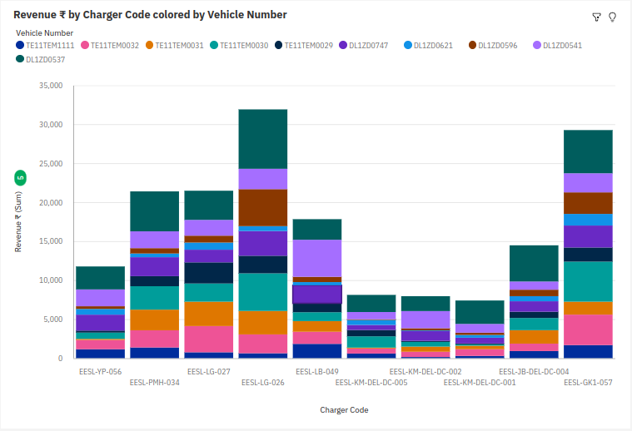

Figure 1: Revenue generated using electric vehicles

*The graph shows data of ten EVs with their respective color and revenue in ₹ generated by a particular EV charger from these 10 EVs. The data*

The information drawn from this stacked column graph are as follows:

* The sum of overall chargers and EVs, the sum of revenue (₹) is nearly ₹1, 72,000.
* EV: DL1ZD0537 whose respective revenue (₹) values add up to over ₹39,000 or 22.9% of the total.
* The most significant values of charger are EESL-LG-026 and EESL-GK1-057, whose respective revenue (₹) add up to over ₹61,000, or 35.6% of total.
* Highest revenue (₹) is generated by EV: DL1ZD0537 at charger: EESL-LG-026.

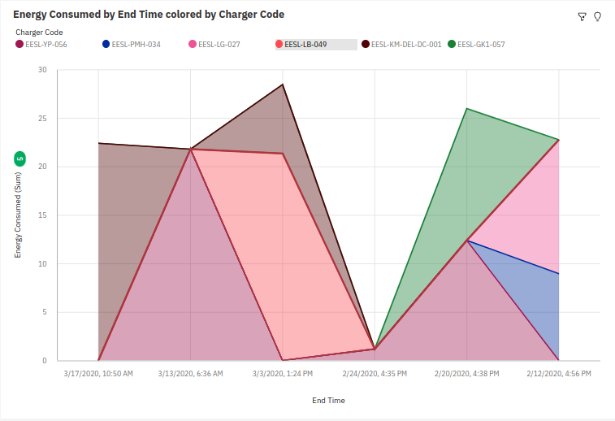

Figure 2: Energy consumed by vehicles

*The graph elaborates about the energy consumed by EV chargers on particular date and time.*

Details as shown in this area graph are:

* For energy consumed the most significant values of chargers are EESL-YP-056, EESL-KM-DEL-DC-001, and EESL-LB-049, whose respective energy consumed values add up to 86.2, or 70.4% of the total.
* Total energy consumed over this period of time totals up to 122.5.

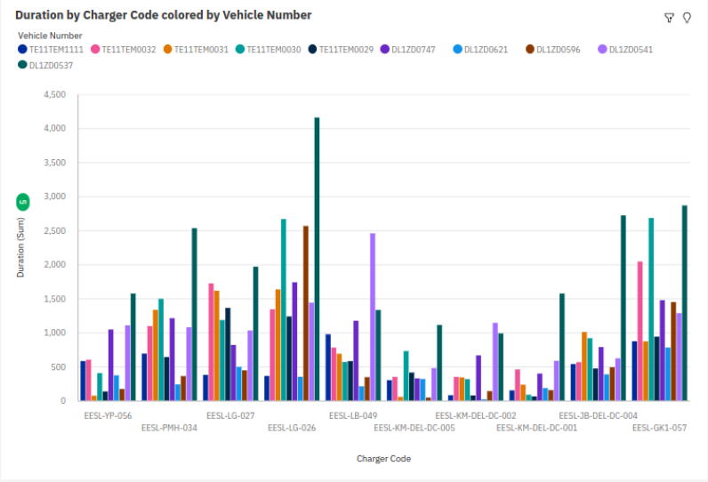

Figure 3: Duration of particular EV on a specific charger

*The total duration each EV took on a particular charger is elaborated in figure 3 as shown above:-*

* EV DL1ZD0537‘s duration values add up to nearly 21 thousand or 23.1% of the total.
* Duration is unusually high when the combination of charger and EV is EESL-LG-026 and DL1ZD0537.
* For duration, the most significant values of charger are EESL-LG-026 and EESL-GK1-057, whose respective duration add up to nearly 33 thousand, or 36.3% of the total.

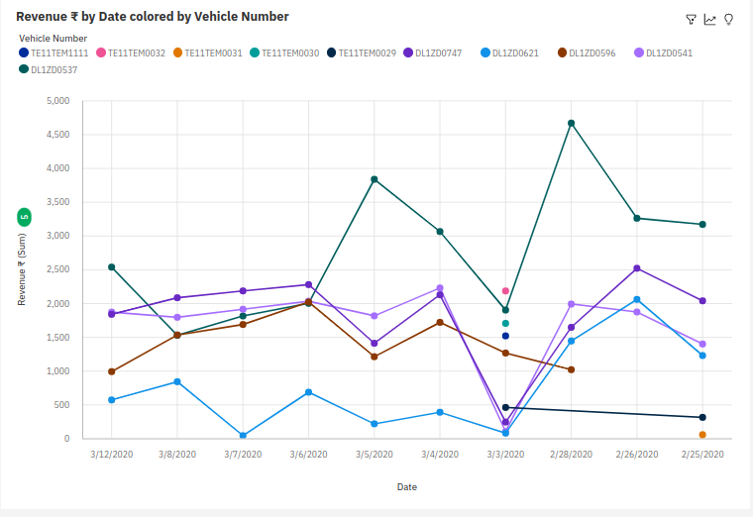

Figure 4: Revenue generated

*The revenue generated by EV chargers on particular date are shown as:-*

* Across all dates, the sum of revenue is over ₹88,000
* EV DL1ZD0537’s revenue sums up to almost ₹28,000, or 31.4% of the total which is highest among all EVs presented in graph 4.
* On date 2020-02-28, whose respected revenue values add up to almost ₹11,000 or 12.2% of the total revenues.

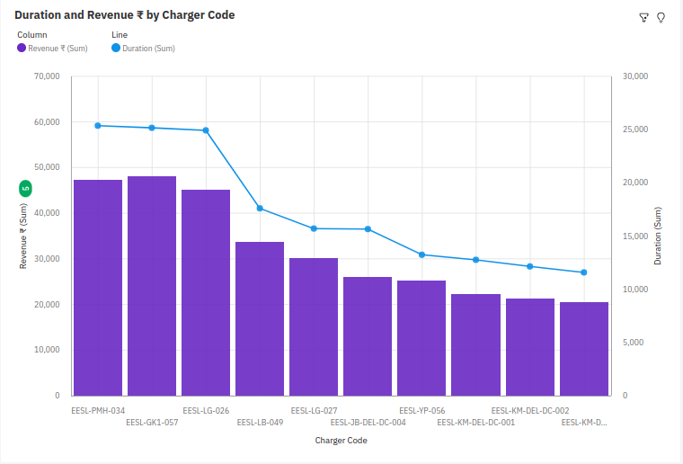

Figure 5: Duration and revenue generated by charger code

*This graph shows data of ten EV charger with their respective revenue (₹) generated while the blue line showing duration of data.*

Data that can be drawn from this line and column graph are given below:

* Revenue is unusually high when charger is EESL-GK1-057, EESL-PMH-034, EESL-LG-026, whose respective values add up to over ₹1,40,000, or 44% of total.
* Duration of chargers EESL-GK1-057, EESL-PMH-034 and EESL-LG-026 add up to over 75000, or 43.4% of the total.
* Revenue ranges from over ₹20,000, when charger is EESL-KM-DEL-DC-005, to over ₹48,000, when charger is EESL-GK1-057.
* Duration ranges from over 12000, when charger is EESL-KM-DEL-DC-005, to over 25000, when charger is EESL-PMH-034.

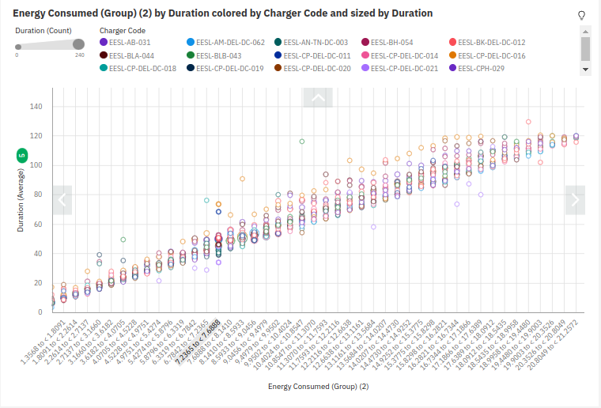

Figure 6: Duration grouped according to energy consumed

The insights drawn out of this graph are:-

* Over the span 0-140 EESL-GK1-057, occurring 731 times, which is 11.8% of total.
* Least used charger is EESL-EC-NOI-DC-002.
* Average duration is about 45.72.
* Duration is unusually high when energy consumed (group) is 22.1617 and above.
* Duration is seen at peak when the charger is EESL-YP-DEL-DC-008 and energy consumed (group) is between 19.9003 and 20.3526.

**7 ADVANTAGES & DISADVANTAGES**

The solution is advantageous to the charging networking industry and also to its users. The solution also recommends the number of chargers needs to be installed in the particular location according to the number of people switching towards green energy resources. It would enable them to cut down the operational cost and improve efficiency by having an adequate number of chargers at every location, also ensuring the chargers are always up (24*7) & working if the energy supply exists in the backup, and are provided with enough energy to manage the overall load in the times of increase of sudden vehicles. A later stage of this project would be focused on providing the customer based experience by recommending which nearby charging station they should head to for saving their time. As they would again be based on the peak times, and charger up-times, that information can easily be forked from this project.

Using EV’s is also cost-effective for the users. The average price of petrol in Delhi closed at Rs 96.76 on September 21, 2022. For every litre, a car averages roughly 16 km, which equates to a cost of Rs 6.0475 per km. An EV on the other hand costs Rs 11.8 per kW, which means a cost of Rs 2.36 per km. To put this into perspective, we have calculated the average cost difference for a month. On average a car is driven for 1500 km every month, on petrol this would cost Rs 9067.5 and using an EV it would be Rs 3540. With efficient charging system management, more users will be inclined towards using an EV that would save on cost and non-conventional energy resources too.

**8 APPLICATIONS**

This solution can be applied at every charging station irrespective of the vehicle that it is meant for. While having sufficient data of the charging station, insights can be derived on when and how many EV’s are being recharged, the charging patterns of them and where the peaks are. Knowing these charging routines of the vehicles can help inform the system operators to manage their networks and optimize the efficiency of EV charging operations.

**9 CONCLUSION**

The project aims to make India pollution free by making efficient use of E-vehicles. Through this project EV charging networks and users, both get benefitted from switching from non-renewable to renewable resources. It also helps to get insights on:-

* The number of EVs gets recharged at a particular location.
* System operators would be able to manage the network by providing optimum energy at a particular power station.
* Would help in locating the peak station that generates the highest revenues.
* Recommends nearest station that may be free to charge the EV.

**10 FUTURE SCOPE**

Our solution currently targets the network providers. It makes it possible for them to assess the incoming and outgoing traffic at each charging location and be able to efficiently manage it in the most optimal way. The future scope of this project would be to make it possible for users to access information similar to what the networks providers are given access to, with the goal that the user would be able to search for the charging stations which are near to his location. Furthermore, be able to see the amount of traffic at these locations and then conclude the charging station they should go to save their time. Also, this project would not only be limited to four wheelers, but instead, it can be used for two wheelers as well, or any electronic vehicle for that matter. With the emergence in EV vehicles, and the journey towards the advancement in shifting from non-renewable to renewable resources, we should see more people shifting to EV’s, and more infrastructure being built towards promoting the use of these vehicles.

**11 BIBILOGRAPHY**

1. Sonali Goel, Renu Sharma, Akshay Kumar Rathore, “A review on barrier and challenges of electric vehicle in India and vehicle to grid optimisation, Transportation Engineering, Volume 4, 2021, 100057, ISSN 2666-691X, https://doi.org/10.1016/j.treng.2021.100057.

(<https://www.sciencedirect.com/science/article/pii/S2666691X21000130>).

2. Jing W, Yan Y, Kim I, Sarvi M. Electric vehicles: A review of network modelling and future research needs. Advances in Mechanical Engineering. 2016;8(1). doi:10.1177/1687814015627981.

3. Helmers, E., Marx, P. Electric cars: technical characteristics and environmental impacts. Environ Sci Eur 24, 14 (2012). <https://doi.org/10.1186/2190-4715-24-14>.

4. Anthony Jnr. Bokolo, “Integrating Electric Vehicles to Achieve Sustainable Energy as a Service Business Model in Smart Cities”, Frontiers in Sustainable Cities, VOLUME=3, YEAR=2021, URL=https://www.frontiersin.org/articles/10.3389/frsc.2021.685716,

DOI=10.3389/frsc.2021.685716, ISSN=2624-9634.

5. Lau, Y.-Y.; Wu, A.Y.; Yan, M.W. A Way Forward for Electric Vehicle in Greater Bay Area: Challenges and Opportunities for the 21st Century. Vehicles 2022, 4, 420-432. https://doi.org/10.3390/vehicles4020025